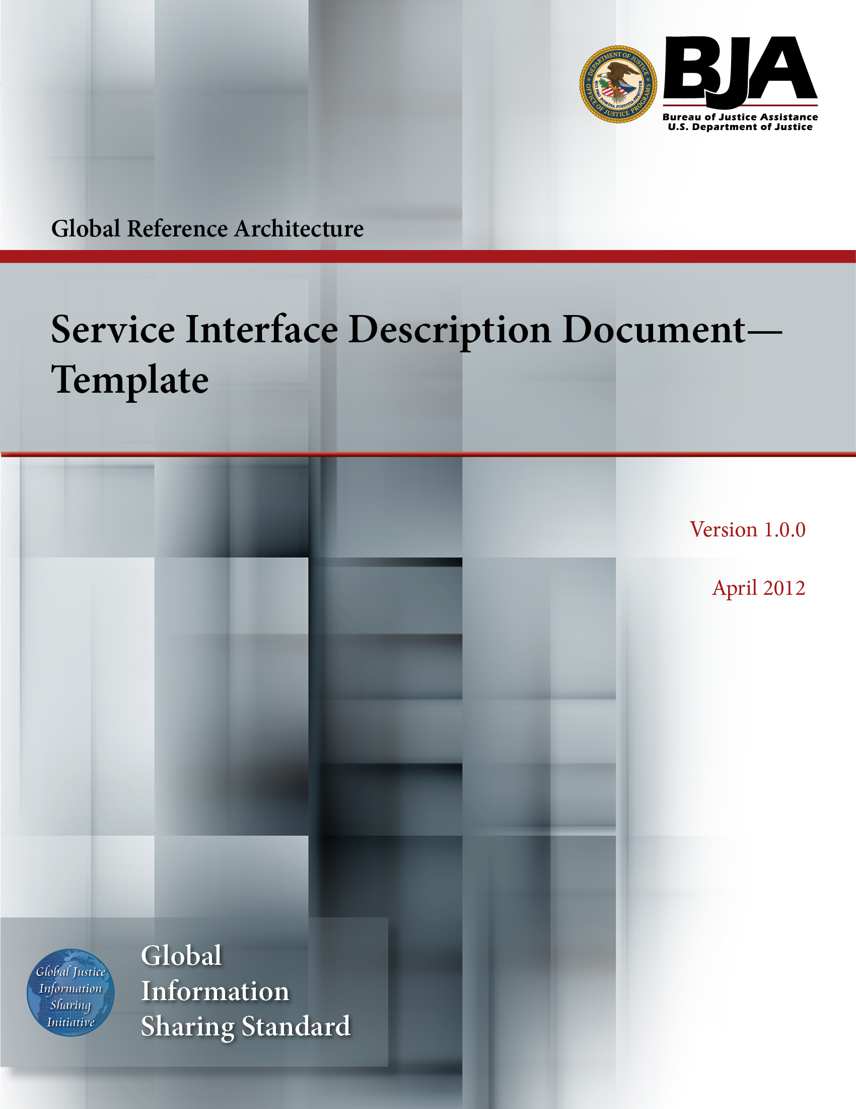


The Global Reference Architecture (GRA)

[Service Name] [Service Abbreviation] [Service Version]

Service Interface Description Document (Template)

Version 1.0.0

By [Name of Organization]

[Month Year]

Table of Contents

Document Conventions ii
1. Introduction 1
2. Physical Model 2
3. Service Interaction Requirements 2
4. Interface Description Requirements 4
5. Message Exchange Patterns 4
6. Message Definition Mechanisms 5
7. Policies and Contracts 6
7.1 Automated Service Policies 6
7.2 Automated Service Contracts 6
7.3 Nonautomated Service Policies and Contracts 6
8. Umbrella Agreements 7
9. Security 7
10. Privacy 7
11. Service Testing 8
Appendix A—References 9
Appendix B—Glossary 10
Appendix C—Document History 11

Document Conventions

[Note: The following template is provided for use with the Service Development Process. Text enclosed in square brackets and/or displayed in blue is included to provide guidance to the author and should be deleted before publishing the document.]

Service Interface Description Document Template

Introduction

In the context of the GRA and Service-Oriented Architecture [soa] in general, a service is the means by which one partner gains access to one or more capabilities offered by another partner. Capabilities generate real-world effects that can be as simple as sharing information or can involve performing a function as part of a complex process or changing the state of other related processes. Government organizations have numerous capabilities and a multitude of partner organizations, both inside and outside of their traditional communities. There are significant benefits for these organizations to share information and have access to each other's capabilities. Achieving interoperability among these organizations requires alignment of business and technical requirements and capabilities. In addition, it is critical to have a consistent way of specifying these requirements and capabilities and sharing them across organizational boundaries. The GRA was developed to facilitate interoperability and to assist in meeting other key requirements common in a complex government information sharing environment. In order to achieve interoperability, a consistent approach must be defined to identify, describe, and package services and their interactions in many different technical environments, across multiple government lines of business, at all levels of government, and with partner organizations.

The GRA defines a service interface as “the means for interacting with a service.” It includes specific protocols, commands, and information exchange by which actions are initiated on the service. A service interface is what a system designer or implementer (programmer) uses to design or build executable software that interacts with the service. That is, the service interface represents the “how” of the interaction. Since the service interface is the physical manifestation of the service, best practices call for service interfaces which can be described in an open-standard, machine-referenceable format (that is, a format which could be automatically processed by a computer).

A Service Specification is a formal document describing the capabilities made available through the service; the service model that defines the semantics of the service by representing its behavioral model, information model, and interactions; the policies that constrain the use of the service; and the service interfaces which provide a means to interacting with the service. A Service Specification is analogous to the software documentation of an Application Programming Interface [api]. It provides stakeholders with an understanding of the structure of the service and the rules applicable to its implementation. It gives service consumers the information necessary for consuming a particular service and service providers the information necessary for implementing the service in a consistent and interoperable way.

The main components of a Service Specification are the Service Description, one or more Service Interface Descriptions, and the schemas and the samples used to implement and test the service.
A Service Description contains information about all aspects of the service which are not directly tied to the physical implementation of the service; in other words, the service interface. A Service Interface Description is a description of the physical implementation; specifically, the service interface used in a specific implementation of the service. Since a service can leverage multiple Service Interfaces, the Service Specification might contain more than one Service Interface Description.

This document is designed as a template for developing a Service Interface Description for a specific service and thus contributes to a consistent approach for describing services.

Physical Model

[This section should describe directly, or by reference, the technical implementation (physical model) of the service implemented via the described service interface (e.g., Web Services definition, schema, electronic policies, and performance/quality of service metrics or other similar structures).

The physical model should sufficiently describe the set of actions implemented by the service interface and the physical endpoint(s) for accessing these actions. This section will also include any relevant details of the Service Interaction Profile (SIP) that will govern how the service interaction requirements of the service will be met. The physical model described in this document will also provide details regarding the message schema(s) for the information model of the service.

The above information can be made part of this document or included by reference in this document.]

[Additional artifacts related to this section's content can be provided in the artifacts folder of the service package or the schema folder of the service package.

[Service Abbreviation] SSP [Service Version]\artifacts

or

[Service Abbreviation] SSP [Service Version]\schema

If such artifacts are provided, they should be referenced in this section. A description of the artifact and a link to it should be provided as part of the reference.]

Service Interaction Requirements

[This section should describe directly, or by reference, the technical implementation (physical model) of the service implemented via the described service interface (e.g., Web Services definition, schema, electronic policies, and performance/quality of service metrics or other similar structures).

The physical model should sufficiently describe the set of actions implemented by the service interface and the physical endpoint(s) for accessing these actions. This section will also include any relevant details of the Service Interaction Profile (SIP) that will govern how the service interaction requirements of the service will be met. The physical model described in this document will also provide details regarding the message schema(s) for the information model of the service.

The above information can be made part of this document or included by reference in this document.

The following chart provides a simple mechanism to identify which interaction requirements are mandatory to support all actions of the service and the industry specifications which can be leveraged to fulfill these requirements.]

Requirements | Mandatory (Yes/No) | Specification
Service Consumer Authentication
Service Consumer Authorization
Identity and Attribute Assertion Transmission
Service Authentication
Message Nonrepudiation
Message Integrity
Message Confidentiality
Message Addressing
Reliability
Transaction Support
Service Metadata Availability
Interface Description Requirements
Service Responsiveness

[The approach to implementation of the service interaction requirements would largely depend on the Service Interaction Profile being implemented. An example of Web Services implementation leveraging WS-Policy is available under the schema folder of the service package.

[Service Abbreviation] SSP [Service Version]\schema\SIP WS 1.2\Policy.wsdl

Additional artifacts related to this section's content can be provided in the artifacts folder of the service package.
[Service Abbreviation] SSP [Service Version]\artifacts

If such artifacts are provided, they should be referenced in this section. A description of the artifact and a link to it should be provided as part of the reference.]

Interface Description Requirements

[This section should contain any interface description requirements dictated by the service actions.

Per the GRA, interface description requirements define common rules of service interaction. Typically, these requirements are not directly related to the capability used by the service consumer, nor are they related to the real-world effect resulting from use of that capability. Rather, the requirements enforce (or support the enforcement of) policies or contracts or otherwise protect the interests of particular business partners or the business organization overall.]

[Additional artifacts related to this section's content can be provided in the service interface description artifacts folder of the service package.

[Service Abbreviation] SSP [Service Version]\service interface description\[service interface n]\artifacts

If such artifacts are provided, they should be referenced in this section. A description of the artifact and a link to it should be provided as part of the reference.]

Message Exchange Patterns

[This section should include the message exchange patterns leveraged by the service actions.

The GRA recognizes the following message exchange patterns:

The fire-and-forget pattern calls for the sender of a message (which could be the service consumer or service) to send the message and not expect a reply message from the recipient. This pattern is useful for one-way transmission of information, such as notification that an event has occurred.

The request-reply pattern calls for the sender of a message to send the message and expect a reply from the recipient.

These two patterns are considered “primitive” patterns, in that they are the fundamental building blocks of more complex information exchange scenarios. For instance, the complex publish-subscribe pattern involves an initial request-reply exchange in which the subscriber subscribes to a service, followed by the service using the fire-and-forget pattern to notify subscribers of an event.

Within the service interface description, the behavioral model should describe message exchanges in terms of these two primitive exchange patterns. Each action can specify a different message exchange pattern..

It is recommended that the table below be used to describe the message exchange patterns used by the service actions.]

Action Name | Message Exchange Patterns
[Service Action] | [primitive message exchange pattern]  If this action is used as part of an implementation of a complex message exchange pattern, information about that pattern should be included here.]

[Additional artifacts related to this section's content can be provided in the artifacts folder of the service package.

[Service Abbreviation] SSP [Service Version]\artifacts

If such artifacts are provided, they should be referenced in this section. A description of the artifact and a link to it should be provided as part of the reference.]

Message Definition Mechanisms

[This section includes information about the message definition mechanism utilized by the service actions.

Per the GRA, message definition mechanisms are closely related to the interface description requirements described above. Unlike interface description requirements, message definition mechanisms establish a standard way of defining the structure and contents of a message.]

[Additional artifacts related to this section's content can be provided in the artifacts folder of the service package.

[Service Abbreviation] SSP [Service Version]\artifacts

If such artifacts are provided, they should be referenced in this section. A description of the artifact and a link to it should be provided as part of the reference.]

Policies and Contracts

[This section includes information about any policies and contracts applicable to the specific implementation of the service.]

Automated Service Policies

[This section will include or reference any automated policies applicable to the implementation of the service.

Future versions of this document will provide additional guidance on the form, structure, and implementation of automated service policies.]

Automated Service Contracts

[This section will include or reference any automated services contracts applicable to implementation of the service.

Future versions of this document will provide additional guidance on the form, structure, and implementation of automated service contracts.]

Nonautomated Service Policies and Contracts

[This section will document requirements for those Service Interfaces that require out-of-band or nonautomated policies and contracts. The section should include all out-of-band requirements not otherwise mentioned in the Service Description that are specific to and required for successful implementation of the service. This may include references to policy, contracts, and enforcement mechanisms and a description of:

  - Policy enforcement mechanisms. Rules and procedures for implementing security, privacy, service usage, and other policies.

  - Pricing/costs. Describes the costs model for the service. The cost model could be free, transaction-based, subscription-based, or another type.

  - Provisioning model and execution context. Describes the rules and procedures for providing the service and its operations.

  - Performance and quality of service metrics such as service availability, response times, and fault condition response processes.

  - Monitoring (auditing). Describes obligations for the collection of metrics for QOS assessment.

Operational constraints. Describes maintenance windows, testing/staging information for new releases, notification processes and emergency procedures, etc., and their monitoring obligations.

Future versions of this document will provide additional guidance on documenting nonautomated policies and contracts for service interfaces.]

Umbrella Agreements

[Some services will be governed by high-level umbrella MOUs that describe the high-level terms and conditions agreed to by both parties. The service interface description should reference any governing MOUs.]

[Additional artifacts related to this section's content can be provided in the artifacts folder of the service package.

[Service Abbreviation] SSP [Service Version]\artifacts
or
[Service Abbreviation] SSP [Service Version]\artifacts\various artifacts\policies and contracts

If such artifacts are provided, they should be referenced in this section. A description of the artifact and a link to it should be provided as part of the reference.]

Security

[This section should contain any information related to the specific security implementation of the service.]

[Additional artifacts related to this section's content can be provided in the artifacts folder of the service package.

[Service Abbreviation] SSP [Service Version]\artifacts
or
[Service Abbreviation] SSP [Service Version]\artifacts\various artifacts\security

If such artifacts are provided, they should be referenced in this section. A description of the artifact and a link to it should be provided as part of the reference.]

Privacy

[This section should contain any information related to the specific privacy implementation of the service.]

[Additional artifacts related to this section's content can be provided in the artifacts folder of the service package.
[Service Abbreviation] SSP [Service Version]\artifacts
or
[Service Abbreviation] SSP [Service Version]\artifacts\various artifacts\privacy

If such artifacts are provided, they should be referenced in this section. A description of the artifact and a link to it should be provided as part of the reference.]

Service Testing

[Service Providers may deploy testing facilities and specific testing environments for their services. Use of these testing facilities and environments may be required or optional. As consumers implement service interfaces, there will be a need to test those implementations. Service providers should document in this section testing options, testing prerequisites, test endpoints, environmental requirements, test schedules, and control procedures and sample data (inputs and expected outputs) for each supported action.]

[Additional artifacts related to this section's content can be provided in the artifacts folder of the service package.

[Service Abbreviation] SSP [Service Version]\artifacts

or

[Service Abbreviation] SSP [Service Version]\artifacts\various artifacts\testing

If such artifacts are provided, they should be referenced in this section. A description of the artifact and a link to it should be provided as part of the reference.]

Appendix A—References

[This section is used to list applicable references.]

[Reference name and description] | [Fully qualified link/path to the reference information]

Appendix B—Glossary

[This section is used to list glossary terms used in the document.]

[Glossary term or acronym] | [Glossary term or acronym description]

Appendix C—Document History

[This section is used to document the history of the service description document.]

Date | Version | Editor | Change



